USING ARTIFICIAL INTELLIGENCE SYSTEMS AND ADVANCED ANALYSIS TO DETECTING

**DIABETIC RETINOPATHY**

TABLE OF CONTENT

Abstract

1. Introduction and Background of Diabetic Retinopathy
2. Literature Review
3. Methodology, Sampling, Data Collection/Selection and Analysis Approach
   1. Model Architecture
   2. Data Collection and Sampling
   3. Analysis on Image
4. Analysis and Findings
5. Evaluation and Discussion
6. Conclusion and Implications
7. References

ABSTRACT

For this research project, deep learning-based approach was used which can be categorized as a field of Artificial Intelligence to accurately classify Diabetic Retinopathy Images gotten with a Fundus Photography, in this approach to accurately do this we leverage on known advances in deep learning and used Transfer Learning as this was a better approach in terms of Computation expensiveness and Time in Training as this helped us to use already trained Model Architecture to achieve a better result on this data. However, the need to solve this problem was needed as a most fields have been incorporating AI to try and speed up the process of performing some specific task, since AI Model are better at doina g completaskssk than simple task and overtime they have been able to beat Humans in this i.e ImageNet Competition. Hence this would reduce the Time, Resources and Man Power to test is a patient is suffering from this disease or Not so as to help prevent one eyesight to prevent blindness as this is most common in People who are suffering from Diabetes. The performance metric used was Accuracy and Cohen-Kappa Method [1].we experimented over a large dataset splitting the data into Train and Validate, before the Result was taken, the essence of this, is to see how good feature engineering of data improves performance

1. Introduction and Background of Diabetic Retinopathy

Diabetic Retinopathy is a kind of complication of diabetes which have an effect notably in the human eye , as it is found to be caused due to severe damage of the blood vessels of sensitive-light tissues at the retina (Back of the Eye), during an initial stage lenitive vision challenges which can obviously lead to total blindness which affects not less than 347million people [3], if it is not quickly detected at the early stage of occurrence, diabetes reduces the sugar level control hence vision complication are easy to be developed.

Ophthalmologist trained in this field depend on the amount and stages of related lesions to group the Diabetic Retinopathy as stated below, Hence the needed to reduce the workload and automate this process with machines/algorithm that are more efficient, as this is a manual and slow process of detecting DR in early stage

Using Deep Learning Systems/algorithm to solve Medical Analysis problems has become a new trend/method as this has proven to be a good solution to conventional patterns i.e Pneumonia Classification, Skin Cancer Classification [5]-[6] as this Algorithm performs better and learn image patterns within a short period of training time of the model. In the dataset used, we have 5 different classes of DR we resolved to solving the problem as a Multi-Class Classification problem

1. Literature Review

In this segment, we would look at different approaches to the DR classification challenge. Early-stage approach to solving this problem was using conventional/traditional Statistical and Machine Learning algorithms before the breakthrough of ImageNet which set a new standard for using CNN for Computer Vision challenges. Acharya et al. [7] ML algorithm implemented for diagnosis such as K-Nearest Neighbors(KNNs), Gaussian Mixture Models (GMMs), and Support Vector Machine first had it breakthrough of solving this challenge as these approaches involve the extraction of features i.e hemorrhages, blood vessel area and microaneurysms exudes were here used as inputs feature in training this classifiers model to achieve an accuracy of 86% and specificity of 86%. Broadbent et al[8]developed a Convolutional Neural Network Architecture Model that was able to engineer features in the retina using data transformation and augmentation techniques for building a classifier model and achieved an accuracy of 75% and sensitivity of 95% since this many CNN approaches and Transfer Learning has been used to solve this notably the Kaggle ATPOS challenge [4]/[9] in which the First place position achieved an accuracy of 93.6% using Inception_resnet_v2 and seresnet50 architecture [10]. Kant et.al [11] leveraged inceptionNetV3 for DR of Each Class reaching an accuracy of 90.9% Michalska, et.al [12]a trained ResNet50, DenseNet, VGGNet and XceptionNet to produce an accuracy of 81.3%

1. Methodology, Sampling, Data Collection/Selection and Analysis Approach
   1. Model Architecture:

Kaiming He et al [13] We used the Resnet34 Architecture as this was trained on a Baseline Network. The Resnet34 is a state of the art model architecture which was able to achieve a top 1% error in the ImageNet Classification Competition, used in ILSVRC 2015 Classification task, CIFAR-10,100 and since the launch of this architecture it has been used in medical imaging classification methods as it uses a lesser layer network that other Resnet Model Architecture and produce a better result. This network uses a residual network as opposed to plain network in which are connected directly. The Diagram Below show how the Resnet34 Architecture was developed by the author using different NN Techniques i.e Dropout, 3 x 3Max pooling, flatten etc. and it involves 33 convolutional layers including a fully connected layer and containing 63.5 million parameters using a Bacth Normalization and an Activation Function Rectification Nonlinearity (ReLU) [14]

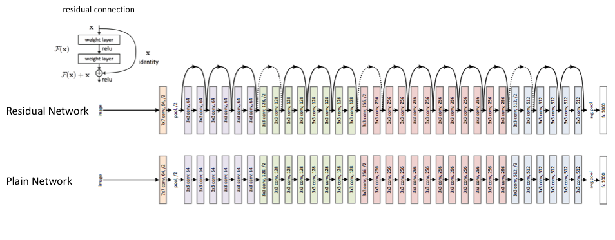

ResNET34 Model Architecture showing Residual Connections

3.2 Data Collection/Selection:

For this paper we used the Asia Pacific Tele-Ophthalmology Society 2019 Dataset which was provided as a competition data on Kaggle this dataset contains of fundus photography image collected with high image quality, variation and resolution which comprises of 20gb data (13k) images. The dataset comprises of noise in the images and labels as this is bound to happen in real-world data set been encountered hence the need for data augmentation and transformation of the images to better suit the model before performing prediction with the images. This images were gotten from multiple clinics in which different camera choices where used based on the clinic hence there was variation in the images to be worked on. Clinician classified each image based on severity as listed below, this labels are then used for our classification model

They are different stages in which Diabetic Retinopathy is grouped as this was part of the data collected and trained which include

1. No Detectable Retinopathy
2. Mild (First Stage):
3. Moderate (Second Stage)
4. Severe Non-Proliferative (Third Stage)
5. Proliferative (Advanced State)

3.3 Analysis of Image:

To provide a good image for classification to the model we need to have a prepared retina image that looks alike, Hence, some camera has different aspect ratios which makes some images have black spots around the eye, these spots act as noise and are not useful to our model hence they were removed and noticed that the size of this spot is different in size in images. To solve this, we used grayscale transformation and identified the black spot surrounding based on the intensity of the pixel, after this, the image was resized to the same shape (1/255) to better fit our model. Depending on the parameters of the eye they vary in shape (Oval, Circle, etc), Hence developing a function to create a circular spot around the center of the eye.

Finally, used Image Transformation to get features by flipping the image horizontal and vertical, increasing the lighting, rotating, and zooming into the image to get a clearer image of the images.

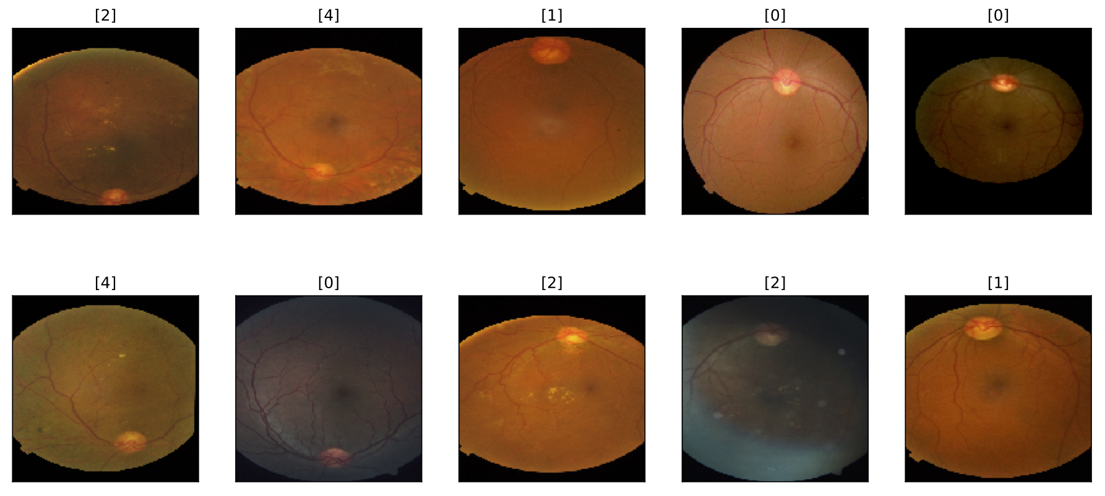

Images Before Applying Data Transformation

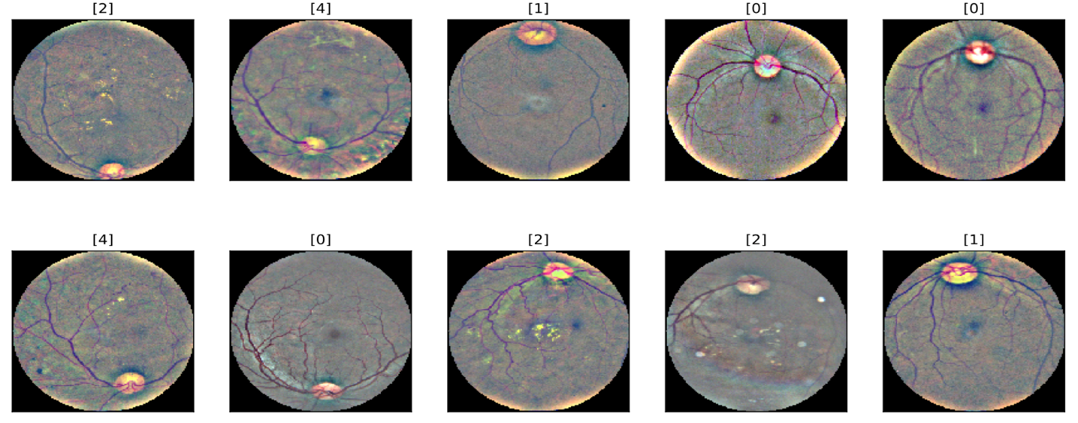

Images After Applying Data Transformation

4. Analysis and Findings:

Adding Table and Data of the Image result gotten after training the model

Each of the model was trained after 4 Epochs, Using a Batch Size of 8, image size of 224 and the Data of the Fundus Images was splitted into a train and validation set of which the validation image data is 20% of the actual data itself and contains each of the 5 classes

Data Splitting

No Mild ---- 1805 Sample Image

1 Mils DR ---- 370 Sample Image

Moderate DR ---- 999 Sample Image

Severe Non Proliferative --- 193 Sample Image

Proliferative --- 295 Sample Image

Training Dataset ----- 2930 Images

Validation Dataset ----- 732 Images

Total Dataset ----- 3662 Images

Learning Rate = 1e-4

Result Without Data Transformation

|  |  |  |  |  |
| --- | --- | --- | --- | --- |
| S/N | Accuracy | Error Rate | Time | Epochs |
| 1 | 72.54 | 27.45 e-2 | 8:38 | 0 |
| 2 | 77.32 | 22.67 e-2 | 9:01 | 1 |
| 3 | 76.63 | 23.36 e-2 | 9:00 | 2 |
| 4 | 77.18 | 22.81 e-2 | 9:18 | 3 |

The accuracy column shows the accuracy of the model after each epoch of Training as it improves after each batch and achieved an accuracy score of 77.1% after just training the dataset over a short period of time (36 minutes)

Result with Data Transformation

|  |  |  |  |  |
| --- | --- | --- | --- | --- |
| S/N | Accuracy | Error Rate | Time | Epochs |
| 1 | 68.30 | 31.69 e-2 | 8:55 | 0 |
| 2 | 72.40 | 27.59 e-2 | 8:47 | 1 |
| 3 | 75.40 | 24.59 e-2 | 8:46 | 2 |
| 4 | 75.13 | 24.86 e-2 | 8:51 | 3 |

The accuracy of our model reduces as data transformation was applied and this could be attributed to different factors which include the Choice of Model, Batch Size, Learning rate, and Number of Epochs used as Longer Epochs and a well-fine-tuned Parameter would produce better results, Hence we decided to convert the Data set to a Binary Classification which includes No DR and DR as all the classes of DR were grouped into one name termed DR whilst Stage 0 referred to as no DR, implementing Data Transformation Techniques on this to see how it performs.

For the Binary Classification we trained on the Same Parameters as above but only changed the Epochs from 4 to 10 as this increased the computing time.

An Accuracy of 97.13% was attained without using the Data Transformation Techniques whilst 97.8% without using Data Transformation Techniques.

Binary Classification Result with Data Transformation

|  |  |  |  |  |
| --- | --- | --- | --- | --- |
| S/N | Accuracy | Error Rate | Time | Epochs |
| 1 | 87.70 | 12.29 e-2 | 9:03 | 0 |
| 2 | 88.66 | 11.3 e-2 | 9:01 | 1 |
| 3 | 94.53 | 5.46 e-2 | 9:05 | 2 |
| 4 | 95.90 | 4.09 e-2 | 9:09 | 3 |
| 5 | 96.72 | 3.27 e-2 | 9:07 | 4 |
| 6 | 95.08 | 4.91 e-2 | 9:08 | 5 |
| 7 | 96.99 | 3.00 e-2 | 9:09 | 6 |
| 8 | 97.13 | 2.86 e-2 | 9:07 | 7 |
| 9 | 96.99 | 3.00 e-2 | 9:17 | 8 |

Binary Classification Result without Data Transformation

|  |  |  |  |  |
| --- | --- | --- | --- | --- |
| S/N | Accuracy | Error Rate | Time | Epochs |
| 1 | 95.49 | 4.50 e-2 | 9:09 | 0 |
| 2 | 92.62 | 7.37 e-2 | 9:00 | 1 |
| 3 | 96.03 | 3.96 e-2 | 9:01 | 2 |
| 4 | 94.53 | 5.46 e-2 | 8:57 | 3 |
| 5 | 96.03 | 3.96 e-2 | 9:04 | 4 |
| 6 | 96.85 | 3.14 e-2 | 9:03 | 5 |
| 7 | 97.54 | 2.45 e-2 | 9:15 | 6 |
| 8 | 97.81 | 2.18 e-2 | 9:14 | 7 |
| 9 | 97.67 | 2.32 e-2 | 9:07 | 8 |
| 10 | 97.26 | 2.73 e-2 | 9:17 | 9 |

5. EVALUATION AND DISCUSSION

From Our Evaluation of the Result gotten, applying Data Transformation proved to not produce a better result both on the Multi-Classification and Binary Classifications as opposed to training the dataset without it, a better feature engineering/ selection of features from the images might produce a good result but not most of the case [10] as some times Data Preprocessing might remove some pertinent features o be used by the model with can thereby result in poor performance, Hence the need for a Domain knowledge to develop a better AI system as this is need to ensure a Robust Model is been developed before been put to use.

6. Conclusion and IMPLICATIONS

In this paper, a research background of using ResNet34 a Convolutional Neural Network Architecture for Classifying Diabetic Retinopathy using the ATPOS data approach was used. [Fuzhen Zhuang](https://arxiv.org/search/cs?searchtype=author&query=Zhuang%2C+F) et.al [17] Leveraging on Transfer Learning with Data augmentation, classification of Different Diabetic Retinopathy Stages was achieved and this model metrics can also be further improved on as this is a research analysis, advanced deep Learning approaches can be tried such Semi-Supervised Learning, Efficient Net, Transformer with CNN.

For practical application the model developed can be deployed on a cloud server to be accessed anywhere or integrated on a device to be used by Clinicians for on-demand services without the need or help of a specialists to operate the system and give result diagnosis, this would serve as an accurate and cost-effective method to diminish the lack of access to DR screening

7. References:

[1] <https://www.knime.com/blog/cohens-kappa-an-overview>

[2] J. Cohen (1960). “A coefficient of agreement for nominal scales”. Educational and Psychological Measurement 20(1):37-46. doi:10.1177/001316446002000104.

[3] G. Danaei, M. Finucane, Y. Lu, G. Singh, M. Cowan, C. Paciorek, J. Lin,  
F. Farzadfar, Y. Khang, G. Stevens et al., “National, regional, and global trends in fasting plasma glucose and diabetes prevalence since 1980: systematic analysis of health examination surveys and epidemiological studies with 370 country-years and 2.7 million participants,” The Lancet,vol. 378, p. 31–40, 2011, n/a

[4] Kaggle, “Kaggle diabetic retinopathy detection challenge,”  
https://www.kaggle.com/c/diabetic-retinopathy-detection, 2015

[5] A. Esteva, B. Kuprel, R. A. Novoa, J. Ko, S. M. Swetter, H. M. Blau, and S. Thrun, “Dermatologist-level classification of skin cancer with deep neural networks,” Nature, vol. 542, p. 115, Jan. 2017

[6] Kaggle “Kaggle Chest Image Data Challenge Available at: <https://www.kaggle.com/code/arbazkhan971/pneumonia-detection-using-cnn-96-accuracy/data>

[7] A. UR, L. CM, N. EY, C. C, and T. T, “Computer-based detection of diabetes retinopathy stages using digital fundus images,” Proceedings of the institution of mechanical engineers, vol. 223, no. 5, pp. 545–553, 2008.

[8] D. Broadbent ,H. Pratt, F. Coenen, S. Harding, and Y. Zheng, “Convolutional

neural networks for diabetic retinopathy,” Procedia Computer Science, vol. 90, pp. 200–205, 12 2016.

[9] Asia Tele-Opthamology Society(APTOS) 2019 Available at:

https://www.kaggle.com/c/aptos2019-blindness-detection

[10]First Place Solution APTOS 2019 Summary Available at:

<https://www.kaggle.com/c/aptos2019-blindness-detection/discussion/108065#latest-624210>

[11] S. Kant, and M. T. Hagos “Transfer learning based detection of diabetic retinopathy from small dataset,” CoRR, vol. abs/1905.07203, 2019.[Online]. Available:

[12] S. Michalska, R. Sarki,K. Ahmed, H. Wang, and Y. Zhang, “Convolutional neural networks for mild diabetic retinopathy detection: An experimental study,” International Journal of Computer Science and Information Security (IJCSIS), 09 2019.

[13] Kaiming He Xiangyu Zhang Shaoqing Ren Jian Sun “Deep Residual Learning for Image Recognition”

[14] Andrew L.Maas Awni Y.Hannum, Andrew Y.Ng “Rectifier Nonlinearities Improve Neural Network Acoustic Models”

[15] Yuhao Niu, Lin Gu, Yitian Zhao, and Feng Lu, Member, IEEE “Explainable Diabetic Retinopathy Detection and Retinal Image Generation”

[16] [Fuzhen Zhuang](https://arxiv.org/search/cs?searchtype=author&query=Zhuang%2C+F), [Zhiyuan Qi](https://arxiv.org/search/cs?searchtype=author&query=Qi%2C+Z), [Keyu Duan](https://arxiv.org/search/cs?searchtype=author&query=Duan%2C+K), [Dongbo Xi](https://arxiv.org/search/cs?searchtype=author&query=Xi%2C+D), [Yongchun Zhu](https://arxiv.org/search/cs?searchtype=author&query=Zhu%2C+Y), [Hengshu Zhu](https://arxiv.org/search/cs?searchtype=author&query=Zhu%2C+H), [Hui Xiong](https://arxiv.org/search/cs?searchtype=author&query=Xiong%2C+H), [Qing He](https://arxiv.org/search/cs?searchtype=author&query=He%2C+Q) “A Comprehensive Survey of Transfer Learning”